Qs11.2 Quick Pick Graphics (4-6)

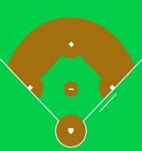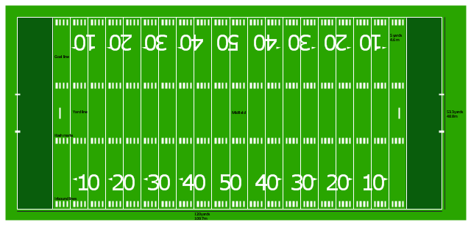



Qs11.2 Quick Pick Graphics (7-9)

11.2 Fix-it (rounds 4-6)

62 yards



 

Main Building

Auditorium

102 yards

59 yards

62 yards

57 yards





Main Building

Auditorium

57 yards

48 yards

98 yards

11.2 Fix-it (rounds 7-9)

Workspace

Conference Room

42 feet

42 feet

63 feet

33 feet